WEDDING PLANNER

|  |  |  |
| --- | --- | --- |
| Supervisor. | **Miss Muniba.** | |
| Batch. | **2110F1** | |
| Group. | **A** | |
| Serial No. | Enrollment Number | Student Name |
| 1. | 1340184 | ASHER AHMED |
| 2. | 1339931 | ALI MUHAMMAD |
| 3. | 1338679 | JUNAID KHAN |
| 4. | 1340161 | ZOYA |

**ACKNOWLEDGEMENT**

**The first, we would like to express my special thanks of gratitude to my teacher Miss MUNIBA, who helped us a lot in finalizing this project**

**within the limited time frame, valuable counselling and assistance for**

**the accomplishment of this project**.

**Secondly, we would also like to thank the e Project team at Aptech**

**Head Office, who gave us the golden opportunity to do this wonderful project about Wedding Planner.**

**Thirdly, we also thank the e Project team, some of the benefits are as under:**

* **Re-enforcement of skills happens in the experiential learning process.**
* **A mentor, ensuring that we do not get drifted, constantly**

**guides us.**

* **It gives us a lot of confidence to face an interview as we have worked on a project. We can explain virtually everything on the subject we have learnt.**

**SYNOPSIS**

“With the help of technology, we are providing people help to Know our wedding website. We are providing relaxing survey to our website. Attached all the information about the main occasion about wedding. So shares the perfect relaxing images through the website for everyone to know about hall decoration services. For the convenience of the people we have provided map for know the route. You have best website for planning website.”

**PROBLEM DEFINITION**

* A website “wedding planner” needs to be developed. The main objective of developing this site is to create a static website for

the wedding planner, from which user can get the details of the wedding such as about wedding planner, venue, theme, contact details, address, images etc. Any dynamic type of database

operations need not be included in the website.

**CUSTOMER REQUIREMENT**

**SPECIFICATION (CRS)**

**The Web site is to be created based on the following**

**Requirements :**

* Home page: It contains basic information about the wedding

planner system.

* About page: It contains all about the wedding planner system

information and their working.

* Gallery page: This page contains all the related images of

Venue, general decoration, themed decoration, dinning arrangements etc.

* Register page: Here user can easily register on the website and confirmation message will be displayed after registering.
* Contact page: user can submit their contact details.
* Login: user can login with credentials and check the related information.
* Forgot password: user can retrieve the password.
* The Home Page should be created with proper sections, graphics and with a suitable logo.
* There should be a “Contact Us” page which will have the Address of the

Company with location should be displayed using Geo Location API

(example: Google Maps) and the mail address which when clicked will

invoke the local mail client from where they can send an email.

**SCOPE OF THE WORK (IN BRIEF)**

The website is to be developed for the Windows Platform using HTML5, JavaScript and bootstrap jQuery. The site should work well in all leading browsers including Chrome, Firefox etc. Our welcome page icon is re-directed to the main web page Ever essential content direct to relative content.

**AGGREGATED SITEMAP & SITEMAP ENGLISH**

**WIREFRAMES**

1. **HOME : (index.html).**

Navigation bar



BACKGROUND

CONTENT

Image. Image. Image. Image.

Content. Content. Content. Content.

FOOTER

**2. SERVICES : (menu bar).**

SERVICES



BACKGROUND

CONTENT

Image. Image. Image. Image.

Content. Content. Content. Content.

Image. Image. Image. Image.

Content. Content. Content. Content.

Image. Image. Image. Image.

Content. Content. Content. Content.

FOOTER

1. **About us : (about.html).**

Navigation bar



BACKGROUND

ABOUT US

CONTENT

Image. Image.

NAME. NAME

ICONS. ICONS.

Image. Image.

NAME. NAME

ICONS. ICONS.

FOOTER

1. **Contact : (contact.html).**

Navigation bar



BACKGROUND

MAP FORM

FOOTER

1. **Registeration: (all pages link).**

Registeration page

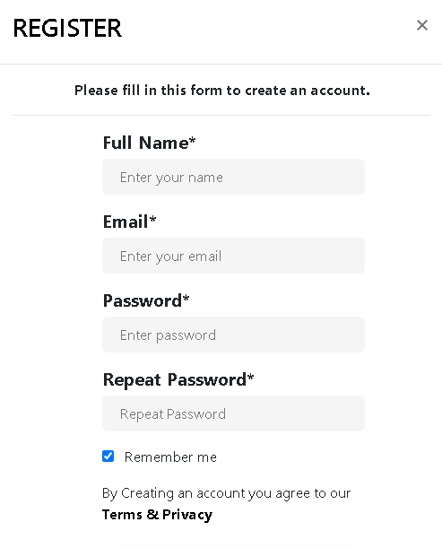

1. **Log In : (all pages link).**

Log In Form

**Sign in**

ICONS. Enter email.

ICONS. Enter password.

Forgot Password?

Log In

Or sign in with :

**TASK SHEET REVIEW 2**

|  |  |  |  |  |  |  |
| --- | --- | --- | --- | --- | --- | --- |
| PAGES NAME | | PROJECT NAME | DATE OF PREPARATION OF TASK | | | |
| S.NO | Task | WEDDING PLANNER | Actual | Actual | Team-mate | Status |
| Start Date | Days | Names |
| 1 | Home Page | 15/03/22 | 1 | Asher | Complete |
| 2 | About Page | 16/03/22 | 1 | Ali | Complete |
| 3 | Service Page | 18/03/22 | 2 | Zoya | Complete |
| 4 | Contact Page | 19/03/22 | 3 | Asher & Zoya | Complete |
| 5 | Registration Form | 20/03/22 | 2 | Junaid | Complete |
| 6 | Log In Form | 22/03/22 | 1 | Ali & Junaid | Complete |
| 7 | e-Project | 24/03/22 | 10 | All-team mates | Complete |

**TASK SHEET REVIEW 3**

|  |  |  |  |  |  |  |
| --- | --- | --- | --- | --- | --- | --- |
| PAGES NAME | | PROJECT NAME | DATE OF PREPARATION OF TASK | | | |
| S.NO | Task | WEDDING PLANNER | Actual | Actual | Team-mate | Status |
| Start Date | Days | Names |
| 1 | Home Page | 25/03/22 | 2 | Asher | Complete |
| 2 | About Page | 27/03/22 | 1 | Ali | Complete |
| 3 | Service Page | 30/03/22 | 3 | Zoya | Complete |
| 4 | Contact Page | 31/03/22 | 1 | Asher & Zoya | Complete |
| 5 | Registration Form | 01/04/22 | 2 | Junaid | Complete |
| 6 | Log In Form | 02/04/22 | 1 | Ali & Junaid | Complete |
| 7 | e-Project | 04/04/22 | 30 | All-team mates | Complete |